PRACTICAL-4

NAME:- Ashwini Ravindra Kadam
PRN:- 202501050017

4.1.1. Pandas - series creation and manipulation
Write a Python program that takes a list of numbers from the user, creates a Pandas series from it, and then calculates the mean of even and odd numbers separately using the groupby and mean() operations.

Hint: You can group the Series based on whether each number is even or odd.

Input Format:
- The user should enter a list of numbers separated by space when prompted.

Output Format:
Product Pairs
Write a Python program that takes the file name of a CSV file as input, reads the data, and performs the following operations:
- The CSV file contains the following columns: Date, Product, Quantity, Price, and City.
- For each date, find all pairs of products that were sold together (i.e., two products sold on the same date).
- Output the product pair/s that was sold most frequently.

CODE:
import pandas as pd

# Take inputs from the user to create a list of numbers numbers = list(map(int, input().split()))

# Create a Pandas series from the list of numbers series = pd.Series(numbers)
# Grouping by even and odd numbers and calculating the mean grouped =series.groupby(series % 2 == 0).mean()

# Display the mean of even and odd numbers with labels
grouped.index = ['Even' if is_even else 'Odd' for is_even in grouped.index]
print("Mean of even and odd numbers:") print(grouped)

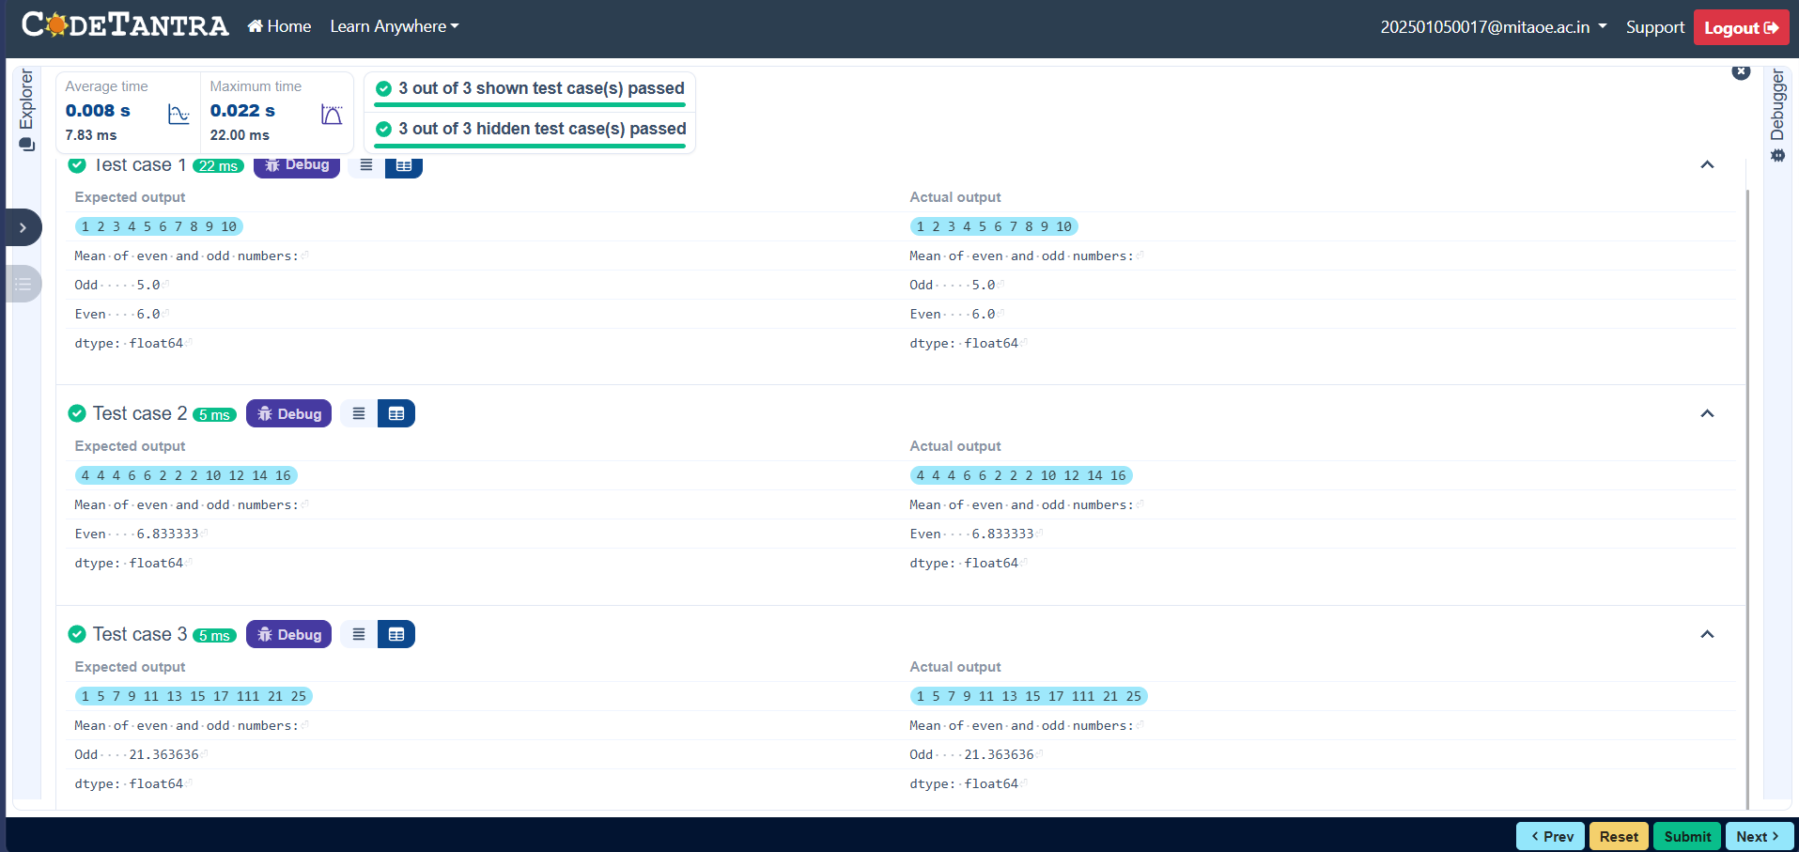
4.1.2. Dictionary to dataframe
A dictionary of lists has been provided to you in the editor. Create a DataFrame from the dictionary of lists and perform the listed operations, then display the DataFrame before and after each manipulation.

Create the DataFrame:
- Convert the dictionary to a Pandas DataFrame.

Add a new row:
- Take inputs from the user for the new row data (name, age).
- Add the new row to the DataFrame.
- Display the DataFrame after adding the new row.

Modify a row:
- Modify a specific row by changing the age. Take the row index and new age value from the user.
- Display the DataFrame after modifying the row.

Delete a row:
- Take the row index to be deleted from the user.
- Remove the specified row.
- Display the DataFrame after deleting the row.

Add a new column:
- Add a column Gender with values taken from the user.
- Display the DataFrame after adding the new column.

Modify a column:
- Convert names to uppercase.
- Display the DataFrame after modifying the column.

Delete a column:
- Remove the Age column.
- Display the DataFrame after deleting the column.
CODE:
import pandas as pd

# Provided dictionary of lists data = {
'Name': ['Alice', 'Bob', 'Charlie'],
'Age': [25, 30, 35],
}

# Convert the dictionary to a DataFrame df = pd.DataFrame(data)

# Display the original DataFrame print("Original DataFrame:") print(df)

# Adding a new row new_name = input("New name: ") new_age = int(input("New age: ")) df.loc[len(df)] = [new_name, new_age]

# Display the DataFrame after adding a new row print("After adding a row:\n",df)

# Modifying a row row_to_modify = int(input("Index of row to modify: ")) new_age_value = int(input("New age: ")) df.at[row_to_modify, "Age"] = new_age_value

# Display the DataFrame after modifying a row print("After modifying a row:") print(df)

# Deleting a row row_to_delete = int(input("Index of row to delete: ")) df = df.drop(index=row_to_delete).reset_index(drop=True)

# Display the DataFrame after deleting a row print("After deleting a row:")
print(df)

# Adding a new column genders = input("Enter genders separated by space: ").split() df["Gender"]=genders

# Display the DataFrame after adding a new column print("After adding a new column:") print(df)

# Modifying a column df["Name"] = df["Name"].str.upper()

# Display the DataFrame after modifying a column print("After modifying a column:") print(df)

# Deleting a column df = df.drop(columns=["Age"])
# Display the DataFrame after deleting a column print("After deleting a column:") print(df)

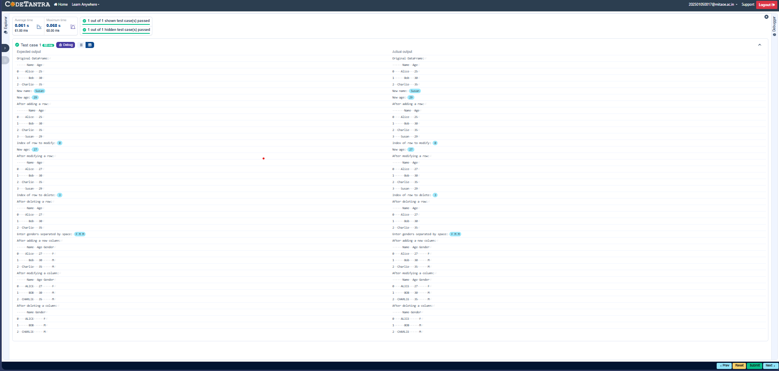
4.1.3. Student Information
Write a program to read a text file containing student information (name, age, and grade) using Pandas. Perform the following tasks:

- Display the first five rows of the data frame.
- Calculate the average age of the students (limit the average age up to 2 decimal places).
- Filter out the students who have a grade above a certain threshold (consider the threshold grade is 'B').
CODE:
import pandas as pd

# Read the text file into a DataFrame file = input() data = pd.read_csv(file, sep="\s+", header=None, names=["Name", "Age", "Grade"])

# write your code here..
print("First five rows:") print(data.head())

average_age = round(data["Age"].mean(), 2) print(f"Average age: {average_age}")

filtered_students = data[data["Grade"]<= "B"] print("Students with a grade up to B") print(filtered_students)

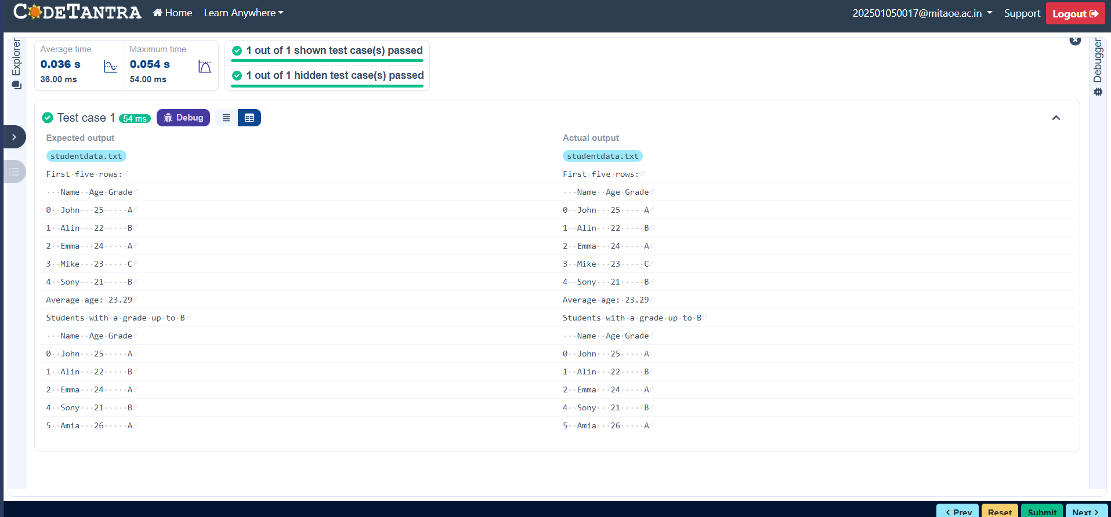
4.2.1. Month with the Highest Total Sales
Write a Python program that takes the file name of a CSV file as input, reads the data, and performs the following operations:
- The CSV file contains the columns: Date, Product, Quantity, Price, and City.
- Group the data by Month and calculate the total sales for each month.
- Find the month with the highest total sales and display it.
- Also, display the total sales for the best month.

Sample Data:
Date,Product,Quantity,Price,City
2025-01-01,Product A,5,20,New York
2025-01-01,Product B,3,15,Los Angeles
2025-01-02,Product A,7,20,New York
2025-01-02,Product C,4,30,Chicago 2025-01-03,Product B,2,15,Chicago
2025-01-03,Product A,8,20,Los Angeles
2025-01-04,Product C,6,30,New York
2025-01-04,Product B,5,15,Los Angeles
2025-01-05,Product A,3,20,Chicago
2025-01-05,Product C,10,30,Los Angeles

CODE:
import pandas as pd

# Prompt the user for the file name file_name = input()

# Load the data df = pd.read_csv(file_name) df["Date"] = pd.to_datetime(df["Date"])

df["Month"] = df["Date"].dt.to_period("M")

df["Total Sales"] = df["Quantity"] * df["Price"]

monthly_sales = df.groupby("Month")["Total Sales"].sum() # Find the month with the highest total sales best_month = monthly_sales.idxmax() highest_sales = monthly_sales.max()

print(f"Best month: {best_month}") print(f"Total sales: ${highest_sales:.2f}")

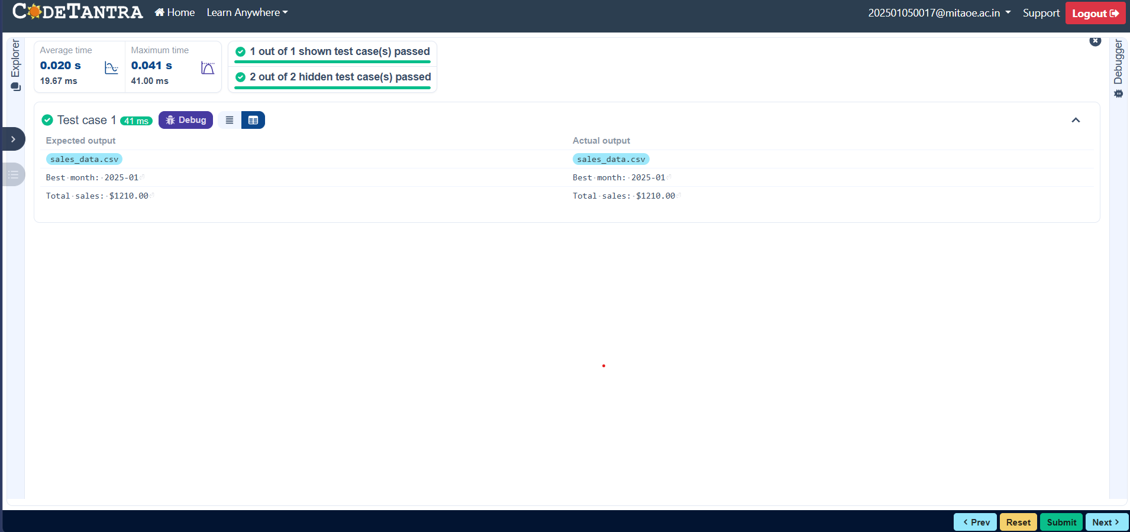
4.2.2. Best Selling Product
Write a Python program that takes the file name of a CSV file as input, reads the data, and performs the following operations:
- The CSV file contains the columns: Date, Product, Quantity, Price, and City.
- Find the product that sold the most in terms of quantity sold.
- Display the product that sold the most and the total quantity sold for that product.

Sample Data:
Date,Product,Quantity,Price,City
2025-01-01,Product A,5,20,New York
2025-01-01,Product B,3,15,Los Angeles
2025-01-02,Product A,7,20,New York
2025-01-02,Product C,4,30,Chicago 2025-01-03,Product B,2,15,Chicago
2025-01-03,Product A,8,20,Los Angeles
2025-01-04,Product C,6,30,New York
2025-01-04,Product B,5,15,Los Angeles
2025-01-05,Product A,3,20,Chicago CODE:
import pandas as pd

# Prompt the user for the file name file_name = input()

# Load the data df = pd.read_csv(file_name)

product_sales = df.groupby("Product")["Quantity"].sum() # Find the product with the highest total quantity sold best_product = product_sales.idxmax() highest_quantity = product_sales.max()

# Display the result print(f"Best selling product: {best_product}") print(f"Total quantity sold: {highest_quantity}")

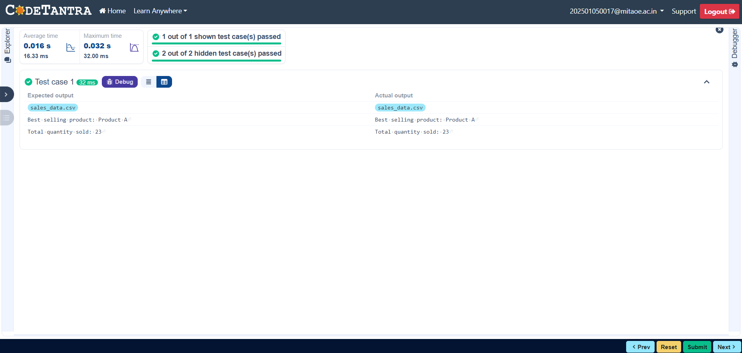

4.2.3. City that Sold the Most Products
Write a Python program that takes the file name of a CSV file as input, reads the data, and performs the following operations:
- The CSV file contains the columns: Date, Product, Quantity, Price, and City.
- Group the data by City and calculate the total quantity of products sold for each city.
- Find the city that sold the most products (based on the total quantity sold).

Sample Data:
Date,Product,Quantity,Price,City
2025-01-01,Product A,5,20,New York
2025-01-01,Product B,3,15,Los Angeles
2025-01-02,Product A,7,20,New York
2025-01-02,Product C,4,30,Chicago
2025-01-03,Product B,2,15,Chicago
2025-01-03,Product A,8,20,Los Angeles
2025-01-04,Product C,6,30,New York
2025-01-04,Product B,5,15,Los Angeles
2025-01-05,Product A,3,20,Chicago 2025-01-05,Product C,10,30,Los Angeles CODE:
import pandas as pd

# Prompt the user for the file name file_name = input()

# Load the data df = pd.read_csv(file_name) city_sales = df.groupby("City")["Quantity"].sum() best_city = city_sales.idxmax() # write the code..

# Display the result print(f"City sold the most products: {best_city}")

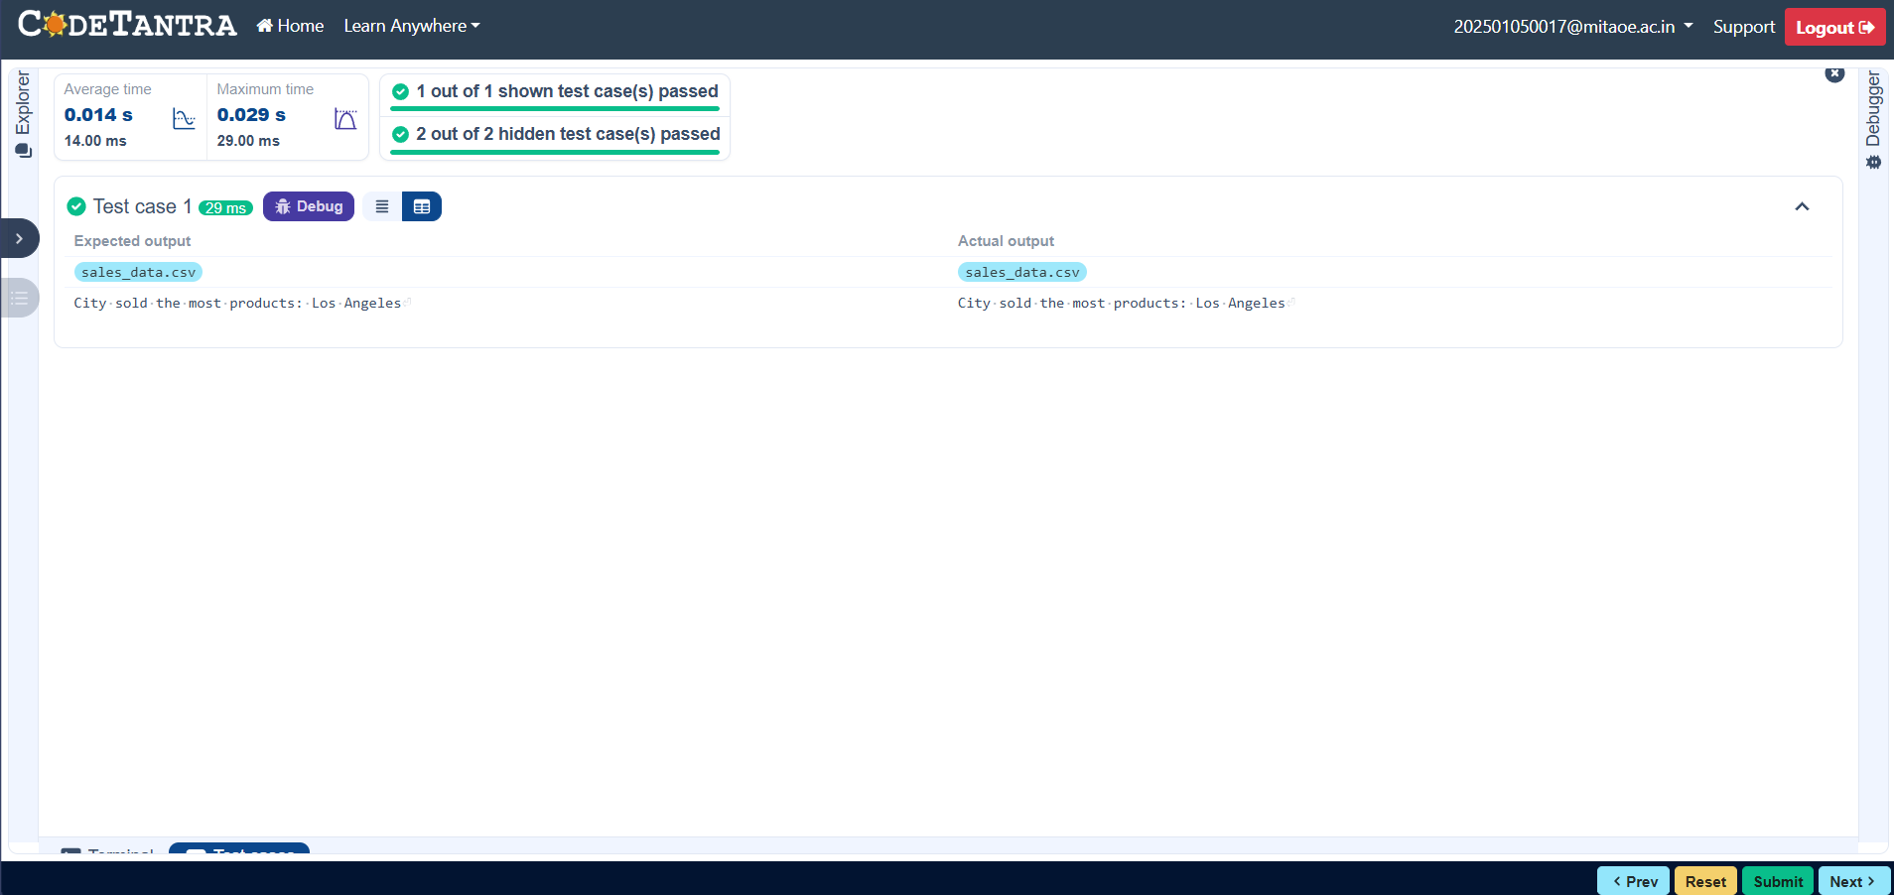
4.2.4. Most Frequently Sold Product Pairs
Write a Python program that takes the file name of a CSV file as input, reads the data, and performs the following operations:
- The CSV file contains the following columns: Date, Product, Quantity, Price, and City.
- For each date, find all pairs of products that were sold together (i.e., two products sold on the same date).
- Output the product pair/s that was sold most frequently.

Sample Data:
Date,Product,Quantity,Price,City
2025-01-01,Product A,5,20,New York
2025-01-01,Product B,3,15,Los Angeles
2025-01-02,Product A,7,20,New York
2025-01-02,Product C,4,30,Chicago
2025-01-03,Product B,2,15,Chicago
2025-01-03,Product A,8,20,Los Angeles
2025-01-04,Product C,6,30,New York
2025-01-04,Product B,5,15,Los Angeles
2025-01-05,Product A,3,20,Chicago 2025-01-05,Product C,10,30,Los Angeles Explanation:
Transactions:
- 2025-01-01: Product A, Product B
- 2025-01-02: Product A, Product C
- 2025-01-03: Product B, Product A
- 2025-01-04: Product C, Product B
- 2025-01-05: Product A, Product C
Now, let's count how often the pairs of products appear together:
- Product A and Product B: Appear in transactions on 2025-01-01 and 2025-0103.
- Product A and Product C: Appear in transactions on 2025-01-02 and 2025-0105.
- Product B and Product C: Appears in transactions on 2025-01-04.
Most Frequent Product Combinations:
- Product A and Product B (2 times)
- Product A and Product C (2 times)

CODE:
import pandas as pd from itertools import combinations from collections import Counter

# Prompt user to input the file name file_name = input()

# Read data from the specified CSV file df = pd.read_csv(file_name)

# write the code grouped = df.groupby("Date")["Product"].apply(list) pairs_counter = Counter() for products in grouped:
pairs = combinations(sorted(products),2) pairs_counter.update(pairs) max_frequency = max(pairs_counter.values()) most_common_pairs =[(pair,freq) for pair, freq in pairs_counter.items() if freq == max_frequency]
# Output the most frequent product pairs for (product1,product2),frequency in most_common_pairs:
print(f"{product1} and {product2}: {frequency} times")

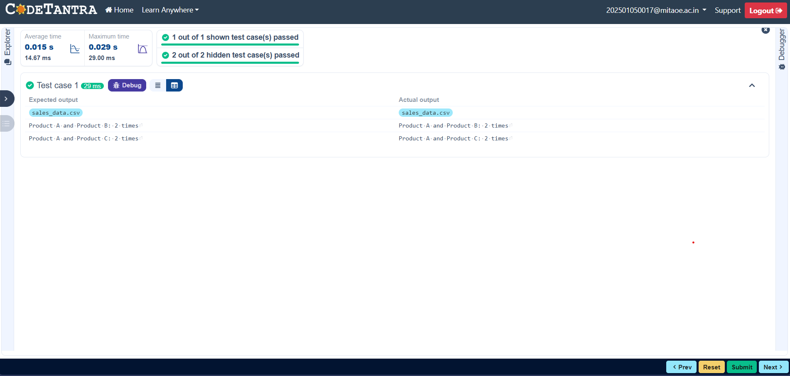
4.2.5. Titanic Dataset Analysis and Data Cleaning
You are provided with the Titanic dataset containing information about passengers on the Titanic. Your task is to write Python code to answer the following questions based on the dataset. For each question, perform necessary data cleaning, transformations, and calculations as required.

- Display the first 5 rows of the dataset.
- Display the last 5 rows of the dataset.
- Get the shape of the dataset (number of rows and columns).
- Get a summary of the dataset (using .info()).
- Get basic statistics (mean, standard deviation, etc.) of the dataset using .describe().
- Check for missing values and display the count of missing values for each column.
- Fill missing values in the ‘Age’ column with the median age.
- Fill missing values in the ‘Embarked’ column with the most frequent value (mode()).
- Drop the ‘Cabin’ column due to many missing values.
- Create a new column, 'FamilySize' by adding the 'SibSp' and 'Parch' columns.

The Titanic dataset contains columns as shown below,
Emba
Sample Data:
PassengerId,Survived,Pclass,Name,Sex,Age,SibSp,Parch,Ticket,Fare,Cabin,Embarked
1,0,3,"Braund, Mr. Owen Harris",male,22,1,0,A/5 21171,7.25,,S
2,1,1,"Cumings, Mrs. John Bradley (Florence Briggs Thayer)",female,38,1,0,PC 17599,71.2833,C85,C
3,1,3,"Heikkinen, Miss. Laina",female,26,0,0,STON/O2. 3101282,7.925,,S
4,1,1,"Futrelle, Mrs. Jacques Heath (Lily May Peel)",female,35,1,0,113803,53.1,C123,S
5,0,3,"Allen, Mr. William Henry",male,35,0,0,373450,8.05,,S
6,0,3,"Moran, Mr. James",male,,0,0,330877,8.4583,,Q
PassengerId | Survived | Pclass | Name | Sex | Age | SibSp | Parch | Ticket | Fare | Cabin
7,0,1,"McCarthy, Mr. Timothy J",male,54,0,0,17463,51.8625,E46,S
8,0,3,"Palsson, Master. Gosta Leonard",male,2,3,1,349909,21.075,,S
9,1,3,"Johnson, Mrs. Oscar W (Elisabeth Vilhelmina
Berg)",female,27,0,2,347742,11.1333,,S
10,1,2,"Nasser, Mrs. Nicholas (Adele Achem)",female,14,1,0,237736,30.0708,,C

CODE:
import pandas as pd import numpy as np

# Load the Titanic dataset data = pd.read_csv('Titanic-Dataset.csv')

# 1. Display the first 5 rows of the dataset print(data.head())

# 2. Display the last 5 rows of the dataset print(data.tail())

# 3. Get the shape of the dataset print(data.shape)

# 4. Get a summary of the dataset (info) print(data.info())

# 5. Get basic statistics of the dataset print(data.describe())

# 6. Check for missing values print(data.isnull().sum())

# 7. Fill missing values in the ‘Age’ column with the median age median_age = data['Age'].median() data['Age'].fillna(median_age,inplace= True)

# 8. Fill missing values in the ‘Embarked’ column with the mode mode_embarked =data['Embarked'].mode() [0] data['Embarked'].fillna(mode_embarked, inplace = True)

# 9. Drop the ‘Cabin’ column due to many missing values data.drop('Cabin', axis=1, inplace=True)

# 10. Create a new column 'FamilySize’ by adding ‘SibSp' and ‘Parch'

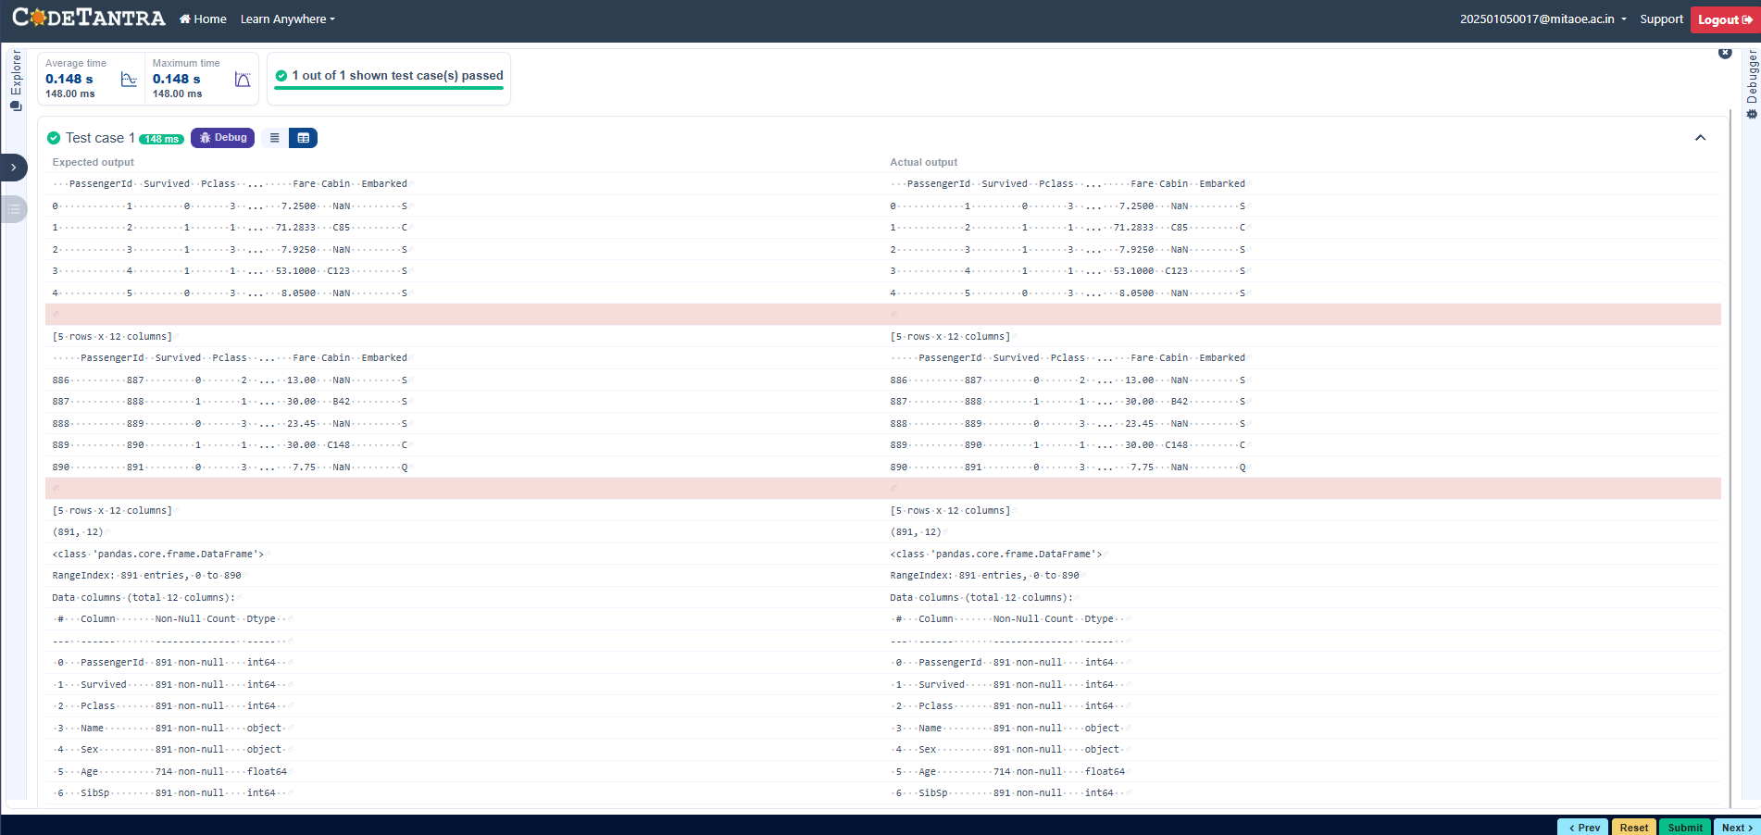
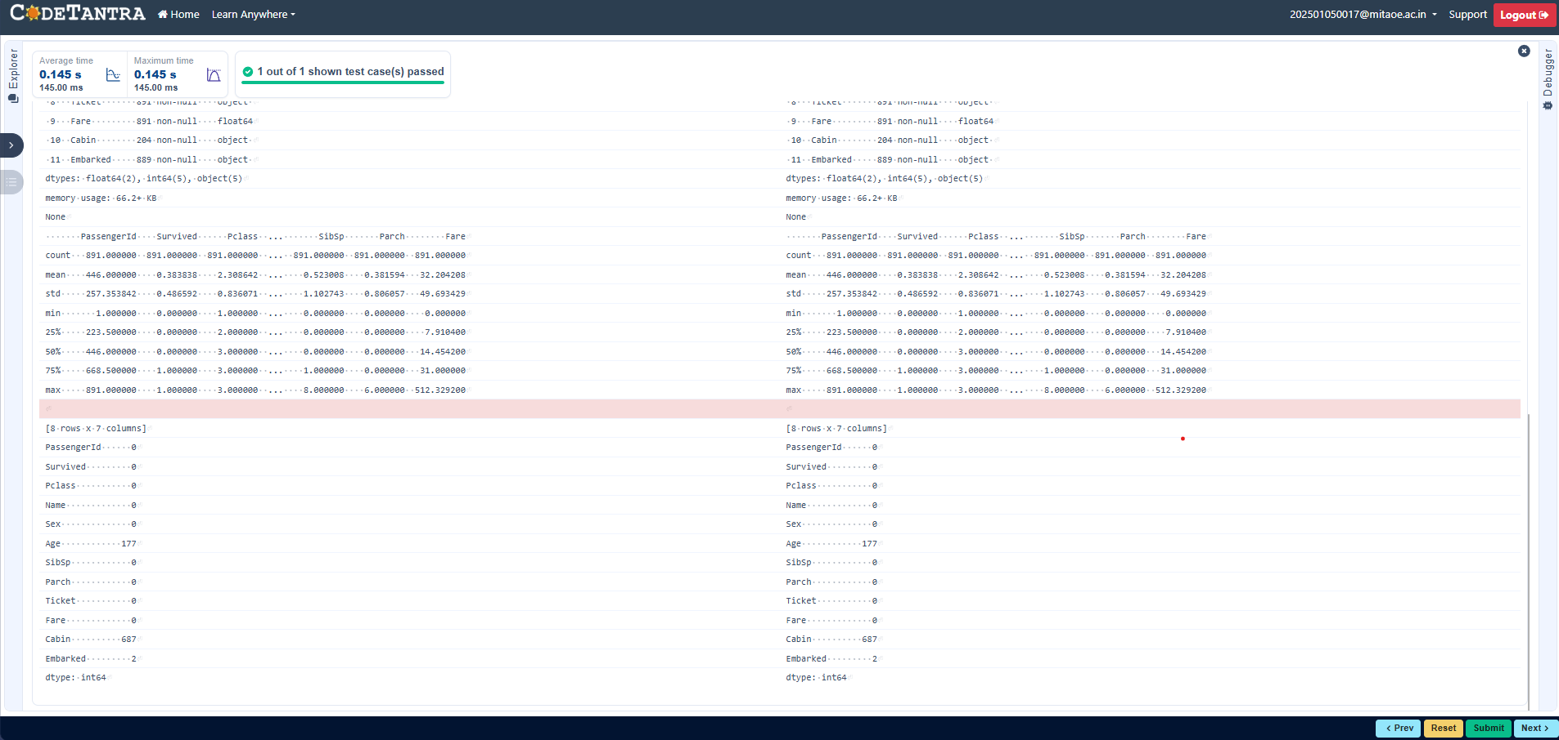

4.2.6. Titanic Dataset Analysis and Data Cleaning - 2
You are provided with the Titanic dataset containing information about passengers on the Titanic. Your task is to write Python code to answer the following questions based on the dataset.
- Create a new column ‘IsAlone’ which is 1 if the passenger is alone (FamilySize = 0), otherwise 0.
- Convert the ‘Sex' column to numeric values (male: 0, female: 1).
- One-hot encode the ‘Embarked’ column, dropping the first category.
- Get the mean age of passengers.
- Get the median fare of passengers.
- Get the number of passengers by class.
- Get the number of passengers by gender.
- Get the number of passengers by survival status.
- Calculate the survival rate of passengers.
- Calculate the survival rate by gender.

The Titanic dataset contains columns as shown below,
PassengerId Survived Pclass Name Sex Age SibSp Parch Ticket Fare Cabin Emba Sample Data:
PassengerId,Survived,Pclass,Name,Sex,Age,SibSp,Parch,Ticket,Fare,Cabin,Embarked
1,0,3,"Braund, Mr. Owen Harris",male,22,1,0,A/5 21171,7.25,,S
2,1,1,"Cumings, Mrs. John Bradley (Florence Briggs Thayer)",female,38,1,0,PC 17599,71.2833,C85,C
3,1,3,"Heikkinen, Miss. Laina",female,26,0,0,STON/O2. 3101282,7.925,,S
4,1,1,"Futrelle, Mrs. Jacques Heath (Lily May Peel)",female,35,1,0,113803,53.1,C123,S
5,0,3,"Allen, Mr. William Henry",male,35,0,0,373450,8.05,,S
6,0,3,"Moran, Mr. James",male,,0,0,330877,8.4583,,Q
7,0,1,"McCarthy, Mr. Timothy J",male,54,0,0,17463,51.8625,E46,S
8,0,3,"Palsson, Master. Gosta Leonard",male,2,3,1,349909,21.075,,S
9,1,3,"Johnson, Mrs. Oscar W (Elisabeth Vilhelmina
Berg)",female,27,0,2,347742,11.1333,,S

10,1,2,"Nasser, Mrs. Nicholas (Adele Achem)",female,14,1,0,237736,30.0708,,C

CODE:
import pandas as pd import numpy as np

# Load the Titanic dataset data = pd.read_csv('Titanic-Dataset.csv') data['FamilySize'] = data['SibSp'] + data['Parch']

# 1. Create a new column ‘IsAlone' (1 if alone, 0 otherwise) data['Alone'] = np.where(data['FamilySize']==0,1,0)

# 2. Convert ‘Sex' to numeric (male: 0, female: 1) data['Sex'] = data['Sex'].map({'male' :0,'female': 1})

# 3. One-hot encode the ‘Embarked' column data = pd.get_dummies(data, columns=['Embarked'], drop_first=True)

# 4. Get the mean age of passengers mean_age = data['Age'].mean() print(mean_age)

# 5. Get the median fare of passengers median_fare = data['Fare'].median() print(median_fare)

# 6. Get the number of passengers by class passengers_by_class = data['Pclass'].value_counts() print(passengers_by_class)

# 7. Get the number of passengers by gender passengers_by_gender = data['Sex'].value_counts().sort_index() print(passengers_by_gender)

# 8. Get the number of passengers by survival status passengers_by_survival = data['Survived'].value_counts().sort_index() print(passengers_by_survival)

# 9. Calculate the survival rate survival_rate = data['Survived'].mean() print(survival_rate)

# 10. Calculate the survival rate by gender gender_survival = data.groupby('Sex')['Survived'].mean() print(gender_survival)

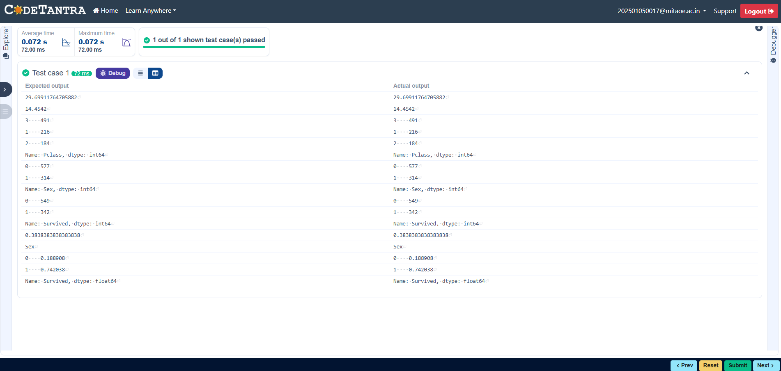

4.2.7. Titanic Dataset Analysis and Data Cleaning - 3
You are provided with the Titanic dataset containing information about passengers on the Titanic. Your task is to write Python code to answer the following questions based on the dataset.

- Calculate the survival rate by class.
- Calculate the survival rate by embarkation location (Embarked_S).
- Calculate the survival rate by family size (FamilySize).
- Calculate the survival rate by being alone (IsAlone).
- Get the average fare by passenger class (Pclass).
- Get the average age by passenger class (Pclass).
- Get the average age by survival status (Survived).
- Get the average fare by survival status (Survived).
- Get the number of survivors by class (Pclass).
- Get the number of non-survivors by class (Pclass).

The Titanic dataset contains columns as shown below,
Emba

Sample Data:
PassengerId,Survived,Pclass,Name,Sex,Age,SibSp,Parch,Ticket,Fare,Cabin,Embarked
1,0,3,"Braund, Mr. Owen Harris",male,22,1,0,A/5 21171,7.25,,S
2,1,1,"Cumings, Mrs. John Bradley (Florence Briggs Thayer)",female,38,1,0,PC 17599,71.2833,C85,C
PassengerId | Survived | Pclass | Name | Sex | Age | SibSp | Parch | Ticket | Fare | Cabin
3,1,3,"Heikkinen, Miss. Laina",female,26,0,0,STON/O2. 3101282,7.925,,S
4,1,1,"Futrelle, Mrs. Jacques Heath (Lily May Peel)",female,35,1,0,113803,53.1,C123,S
5,0,3,"Allen, Mr. William Henry",male,35,0,0,373450,8.05,,S
6,0,3,"Moran, Mr. James",male,,0,0,330877,8.4583,,Q
7,0,1,"McCarthy, Mr. Timothy J",male,54,0,0,17463,51.8625,E46,S
8,0,3,"Palsson, Master. Gosta Leonard",male,2,3,1,349909,21.075,,S
9,1,3,"Johnson, Mrs. Oscar W (Elisabeth Vilhelmina
Berg)",female,27,0,2,347742,11.1333,,S
10,1,2,"Nasser, Mrs. Nicholas (Adele Achem)",female,14,1,0,237736,30.0708,,C

CODE:
import pandas as pd import numpy as np

# Load the Titanic dataset
data = pd.read_csv('Titanic-Dataset.csv') data['FamilySize'] = data['SibSp'] + data['Parch'] data['IsAlone'] = np.where(data['FamilySize'] > 0, 0, 1) data = pd.get_dummies(data, columns=['Embarked'], drop_first=True)

# 1. Calculate the survival rate by class print(data.groupby('Pclass')['Survived'].mean())

# 2. Calculate the survival rate by embarked location print(data.groupby('Embarked_S')['Survived'].mean())

# 3. Calculate the survival rate by family size print(data.groupby('FamilySize')['Survived'].mean()) # 4. Calculate the survival rate by being alone print(data.groupby('IsAlone')['Survived'].mean())

# 5. Get the average fare by class print(data.groupby('Pclass')['Fare'].mean())

# 6. Get the average age by class print(data.groupby('Pclass')['Age'].mean())

# 7. Get the average age by survival status print(data.groupby('Survived')['Age'].mean())

# 8. Get the average fare by survival status print(data.groupby('Survived')['Fare'].mean()) # 9. Get the number of survivors by class print(data[data['Survived'] == 1]['Pclass'].value_counts())

# 10. Get the number of non-survivors by class print(data[data['Survived'] == 0]['Pclass'].value_counts())

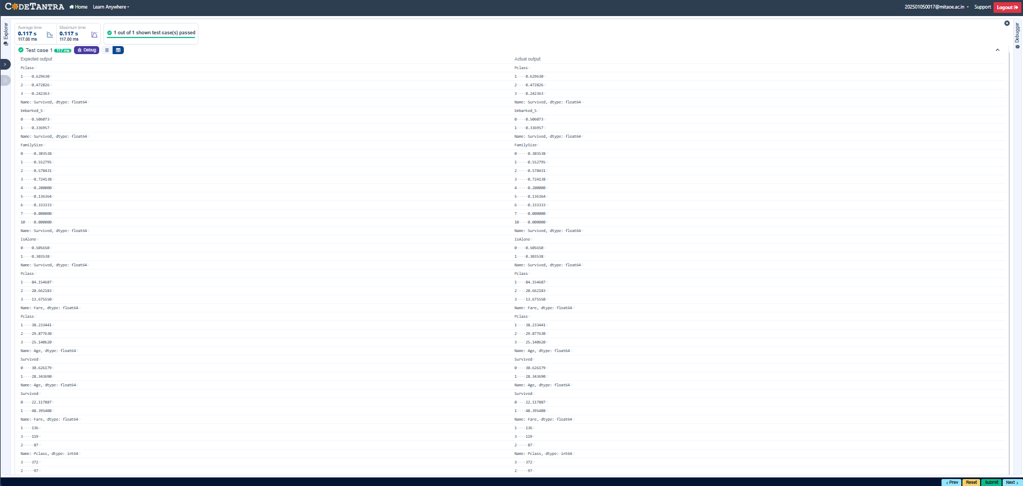

4.2.8. Titanic Dataset Analysis and Data Cleaning - 4
You are provided with the Titanic dataset containing information about passengers on the Titanic. Your task is to write Python code to answer the following questions based on the dataset.

- Get the number of survivors by gender (Sex).
- Get the number of non-survivors by gender (Sex).
- Get the number of survivors by embarkation location (Embarked_S).
- Get the number of non-survivors by embarkation location (Embarked_S).
- Calculate the percentage of children (Age < 18) who survived.
- Calculate the percentage of adults (Age >= 18) who survived.
- Get the median age of survivors.
- Get the median age of non-survivors.
- Get the median fare of survivors.
- Get the median fare of non-survivors.

The Titanic dataset contains columns as shown below,
Emba

Sample Data:
PassengerId,Survived,Pclass,Name,Sex,Age,SibSp,Parch,Ticket,Fare,Cabin,Embarked
1,0,3,"Braund, Mr. Owen Harris",male,22,1,0,A/5 21171,7.25,,S
2,1,1,"Cumings, Mrs. John Bradley (Florence Briggs Thayer)",female,38,1,0,PC 17599,71.2833,C85,C
3,1,3,"Heikkinen, Miss. Laina",female,26,0,0,STON/O2. 3101282,7.925,,S
4,1,1,"Futrelle, Mrs. Jacques Heath (Lily May Peel)",female,35,1,0,113803,53.1,C123,S
5,0,3,"Allen, Mr. William Henry",male,35,0,0,373450,8.05,,S
PassengerId | Survived | Pclass | Name | Sex | Age | SibSp | Parch | Ticket | Fare | Cabin
6,0,3,"Moran, Mr. James",male,,0,0,330877,8.4583,,Q
7,0,1,"McCarthy, Mr. Timothy J",male,54,0,0,17463,51.8625,E46,S
8,0,3,"Palsson, Master. Gosta Leonard",male,2,3,1,349909,21.075,,S
9,1,3,"Johnson, Mrs. Oscar W (Elisabeth Vilhelmina
Berg)",female,27,0,2,347742,11.1333,,S
10,1,2,"Nasser, Mrs. Nicholas (Adele Achem)",female,14,1,0,237736,30.0708,,C

